Project Title:
THE FOF-DESIGNER:
DIGITAL DESIGN SKILLS FOR FACTORIES OF THE FUTURE

Project Acronym:
DigiFoF

Project logo

Grant Agreement number:
2018-2533 / 001-001

Project Nr. 601089-EPP-1-2018-1-RO-EPPKA2-KA

Subject:
D2.3 WEB PLATFORM

Dissemination Level:
PUBLIC

Lead Organization:
BOC

Project Coordinator:
ULBS

Contributors:
All partners

Reviewers:
____________

Revision | Preparation date | Period covered | Project start date | Project duration
V1 | March 2019 | Month 1-3 | 01/01/2019 | 36 Months
V2 | September 2019 | Month 1-9 | 01/01/2019 | 36 Months
This project has received funding from the European Union’s EACEA Erasmus+ Programme Key Action 2 - Knowledge Alliances under the Grant Agreement No 2018-2533 / 001-001

Table of content

1 EXECUTIVE SUMMARY 4
2 OMiLAB4FoF web platform access data and installation guide 5
I. Back-end deployment 5
II. Frond-end deployment 11
3 Conclusion 14

EXECUTIVE SUMMARY

This deliverable accompanies the update release of the DigiFoF web platform V2. The information provided is hence mainly technical in nature. The purpose is to provide the reader with the information on installation prerequisites, access data to web platform files as well as installation guide.
The content on this deliverable can also be accessed at:
http://boc-pl.com/digifof/D2.3/webplatformmanual.html

OMiLAB4FoF web platform access data and installation guide
This tutorial describes all necessary steps required to deploy the web platform V2 for your Laboratory.
The web platform is using an open source micro-service architecture based on Olive made available by OMiLAB. Main component of web-platform is developed with Open Source Strapi headless CMS
Download installation files from:
http://boc-pl.com/digifof/v2/DigiFoF-webportal-v2.zip
This manual is based on Windows 10 (also tested in Ubuntu 18)
Prerequisites to download and install before deployment:
-latest version of node (tested 10.15.3)
-latest version of npm (tested 6.4.1)
-latest version of postgresql (tested 10.10)
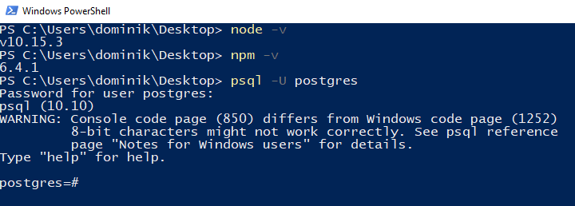
Manual consists of two parts: back-end and front-end.

I. Back-end deployment

I.1 Extract provided project archive or clone project repository (if applicable).
I.2 Open command prompt/windows powershell/terminal inside project folder
I.3 run:
npm install
I.4 Adjust config for database connection (set user/pass/port/host as environmental variables) or type it in '\config\environments\production\database.json'.
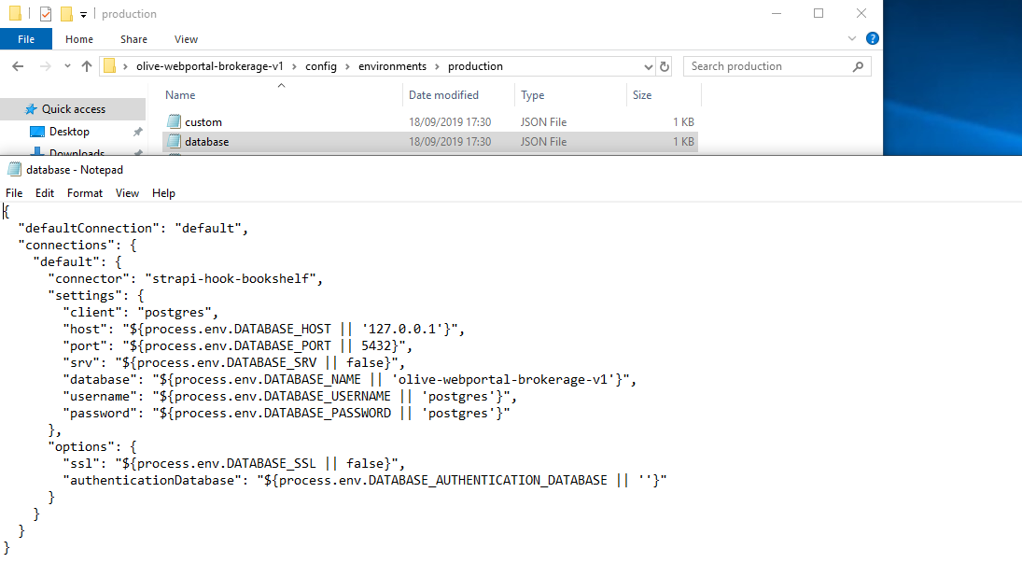
Note, one of the configurations is the name of the database. It should be created beforehand (for example using pgadmin gui, that comes default with postgres installation).

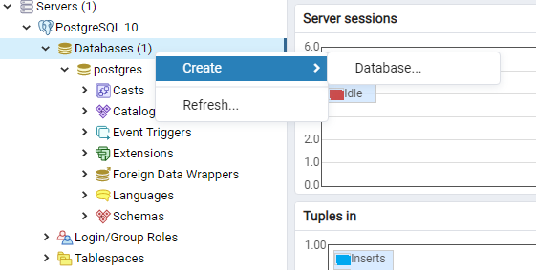
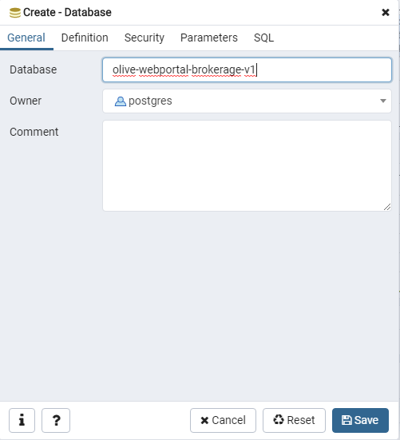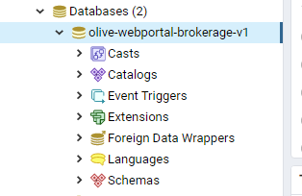

Database user set in config has to have all the rights to the database.
Environmental variables names:
process.env.SITE_SECRET (secret key needed to validate captcha for user registrations)
alternatively in ‘\middlewares\validateUser\index.js’
process.env.PORT (internal port of application, 1337 by default)
process.env.PROXY_ENABLE (enable proxy support)
process.env.PROXY_SSL (enable ssl support)
process.env.PROXY_HOST (host, where your app is at)
process.env.PROXY_PORT (port of hosted app)
alternatively in '\config\environments\production\server.json'.
process.env.DATABASE_HOST
process.env.DATABASE_PORT
process.env.DATABASE_NAME
process.env.DATABASE_USERNAME
alternatively in '\config\environments\production\database.json'.
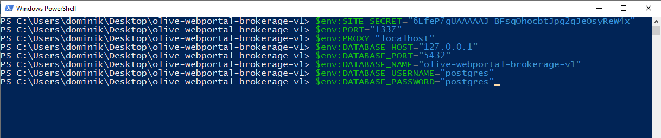
You need to provide proxy config in '\config\environments\production\server.json', so that account confirmation emails would point to proper url (replace „host” value with your own).
For testing and hosting on localhost, just remove config part below:
"proxy": {
"enabled": "${process.env.PROXY_ENABLE || true}",
"ssl": "${process.env.PROXY_SSL || true}",
"host": "${process.env.PROXY_HOST || 'digifof-brokerage-cms.herokuapp.com'}" ,
"port": "${process.env.PROXY_PORT || 443}"
},
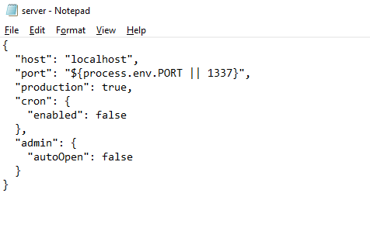
I.5 run:
npm run build
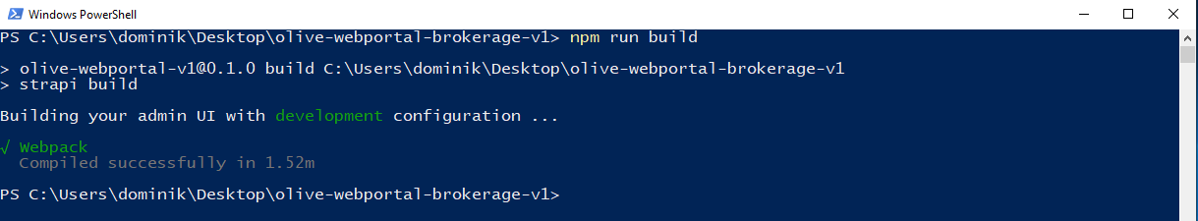
npm run production
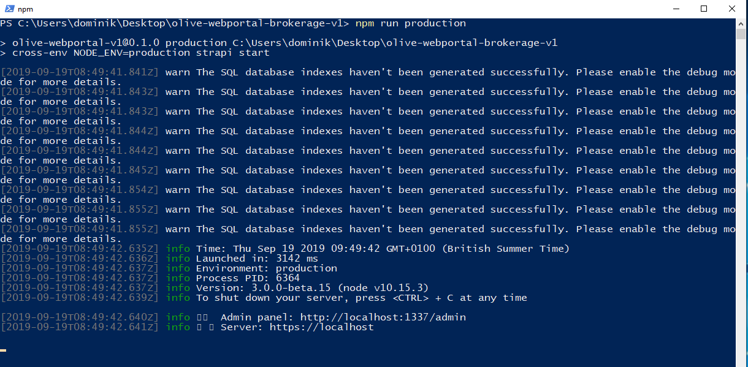
By default, your application will run on localhost, port 1337 and your admin dashboard would be available at:
http://localhost:1337/admin
Above is configurable in '\config\environments\production\server.json' - also environmental variable is an option.
To be able to receive proper account confirmation emails, please also fill in your proxy settings if host is different from localhost.
I.6 Now, after accessing admin panel, you can create your administrator account.
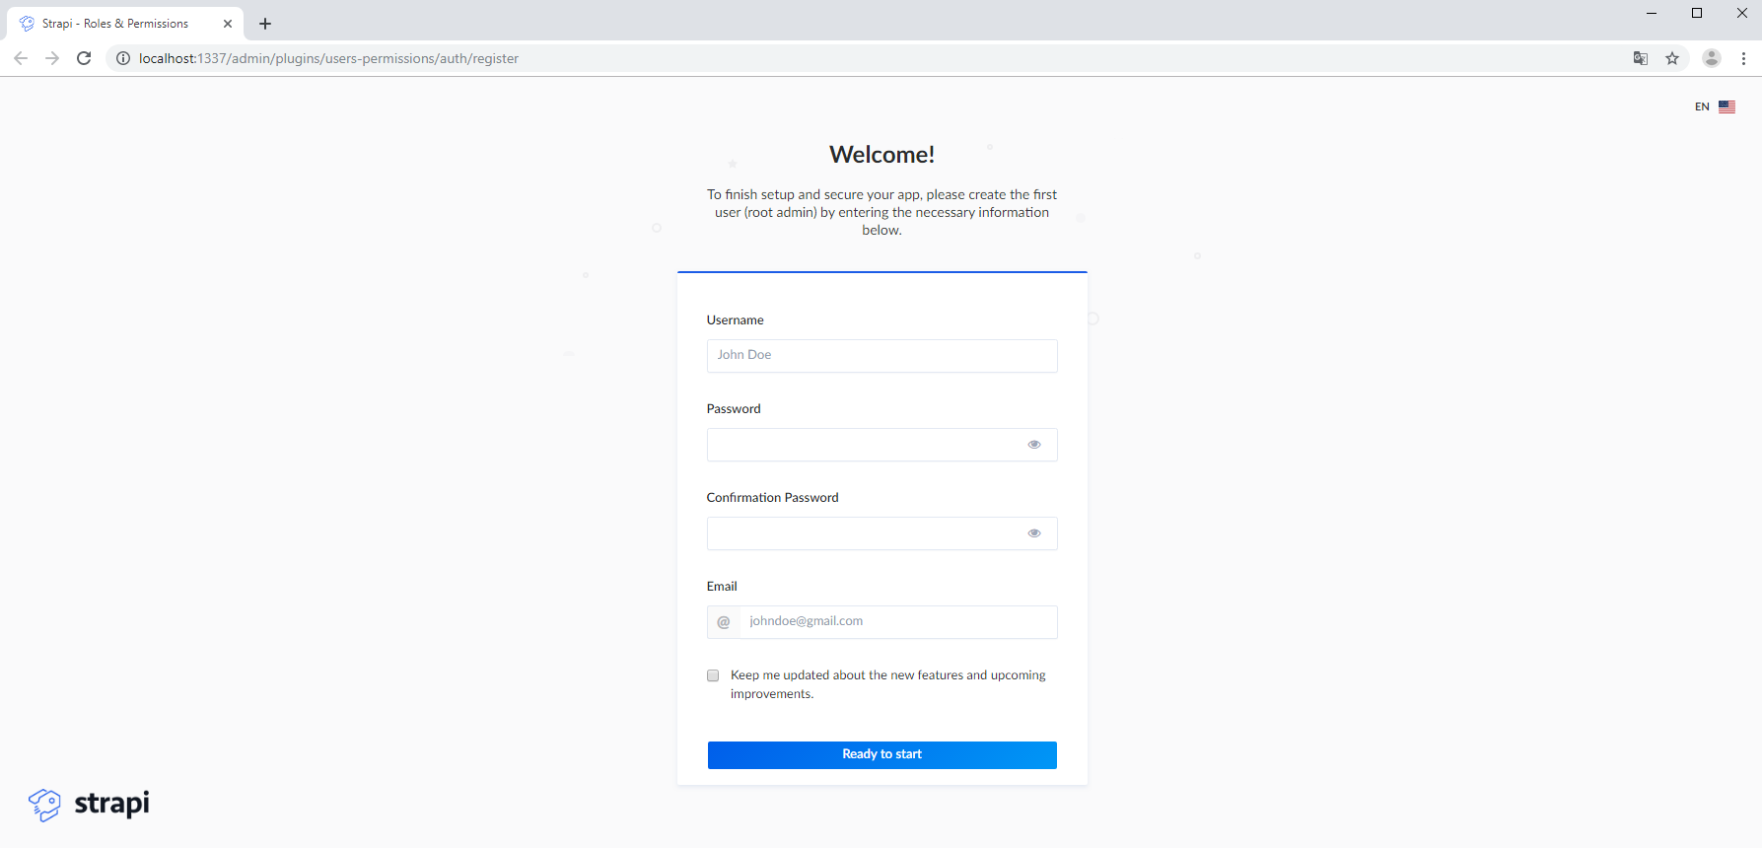
If you would like to use migration package, to see example content, now is the time, when database is empty - just run provided sql commands (migrationbrokerage.sql) on the database you created.
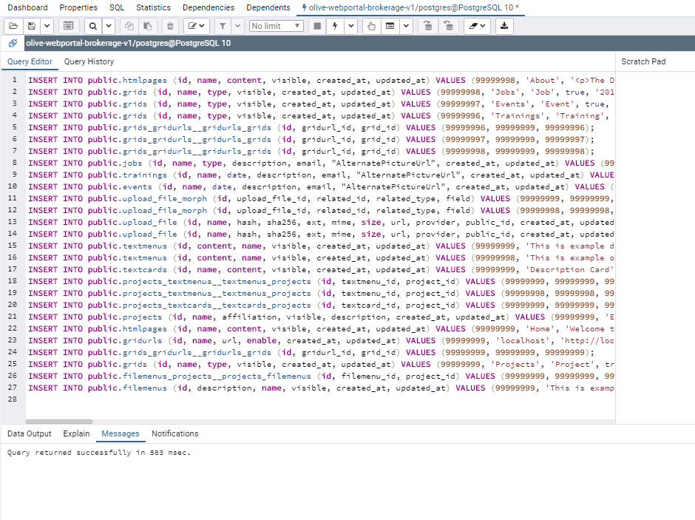
Create your admin account and log in.
I.7 Set user permissions to view content, that you would like to display (this could be done in Plugins->Roles&Permissions->Public)
As a default, you should set permission to 'find' and 'findone' for all public roles for all predefined content types (remember about saving – button in top right corner).
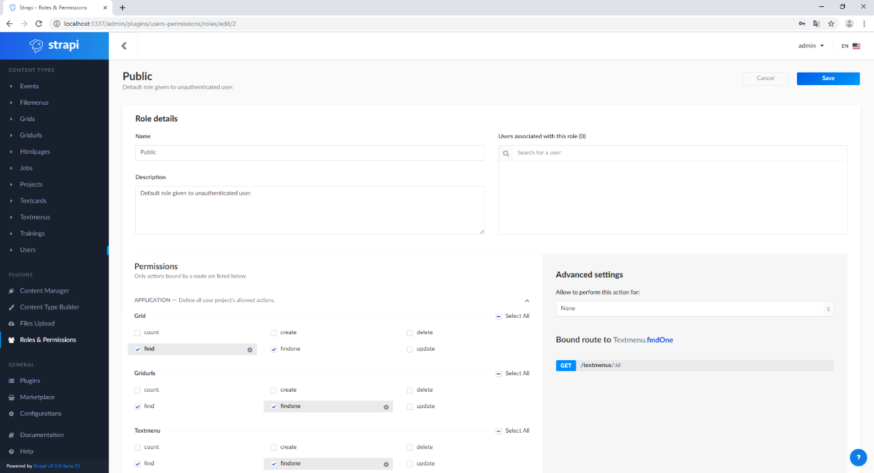
I.8 Turn on new user account confirmation in Plugins->Roles&Permissions->Advanced Settings
Also provide redirection url to your front-end application, so users could be taken there after account confirmation (eg. http://localhost:4000/activated).
Remember, that after registering and signing in, users will get default role 'Authenticated'. Don't forget to give them proper permissions, same as you did with 'Public' role or they will be not able to see any content after signing in!
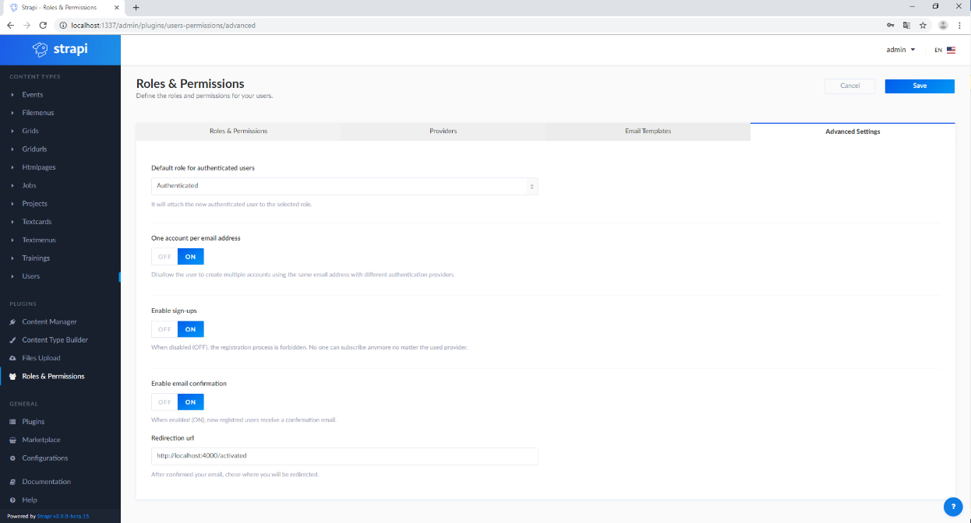
I.9 Adjust your email server settings if you would like to recover passwords and confirm user accounts: plugins->email(cogwheel icon)->production.
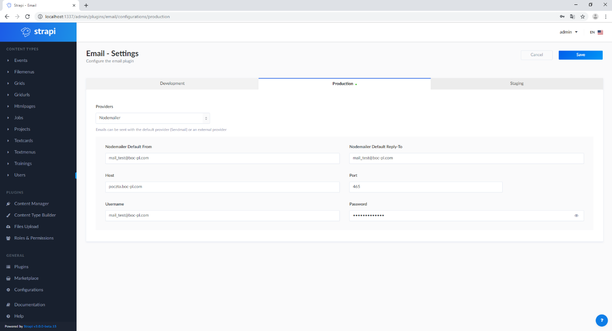
I.10 Content creation
New content could be created, by selecting names of content types and clicking 'Add New [contenttype]' button.
After filling in required fields and clicking 'Save', new content item will be created in database.
Some fields are relations between content types. One of more important relation examples is one between 'Grid' and 'Gridurl' - to be able to use 'Grid' properly, you must create one or more 'Gridurl' items and link it with desired 'Grid' item, so the 'Grid' component in front-end application would know, where to look for data.
Please use unique names for htmlpages and grids - otherwise you will run into unexpected behaviour in frontend.

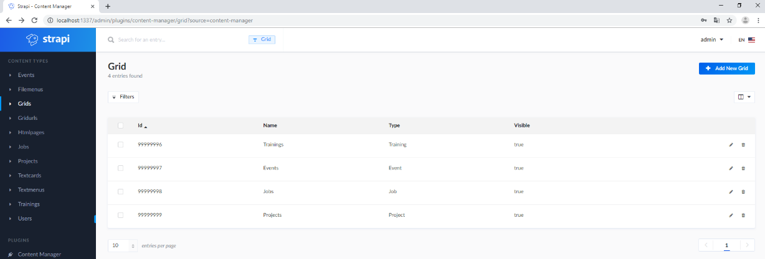

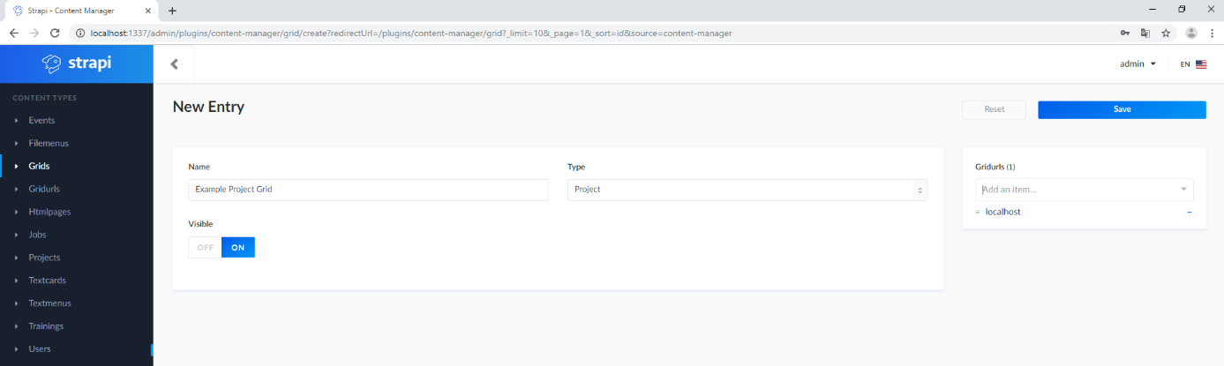

These are the most basic configuration options for back-end part of the portal.
Since web platform is created using Strapi headless cms, for more advanced configuration options, you could look at source documentation: https://strapi.io/documentation/3.0.0-beta.x/

II. Frond-end deployment

II.1 Extract provided project archive or clone project repository (if applicable).
II.2 Open command prompt/windows powershell/terminal inside project folder
II.3 run:
npm install
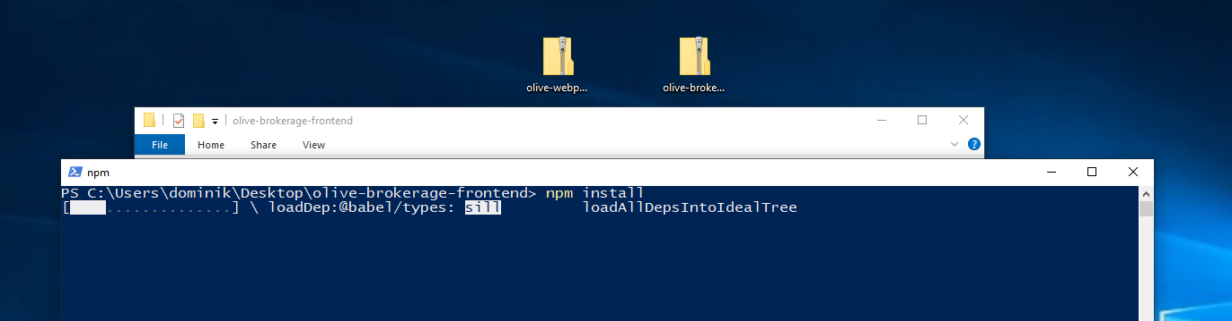
II.4 Adjust config in src/config.js file:
Most importantly backendurl and frontendurl - to enable communication between elements of portal.
You can also adjust styling for select components such as header or footer.
Sometimes you are not limited to styling options provided- it might be possible to add new ones.
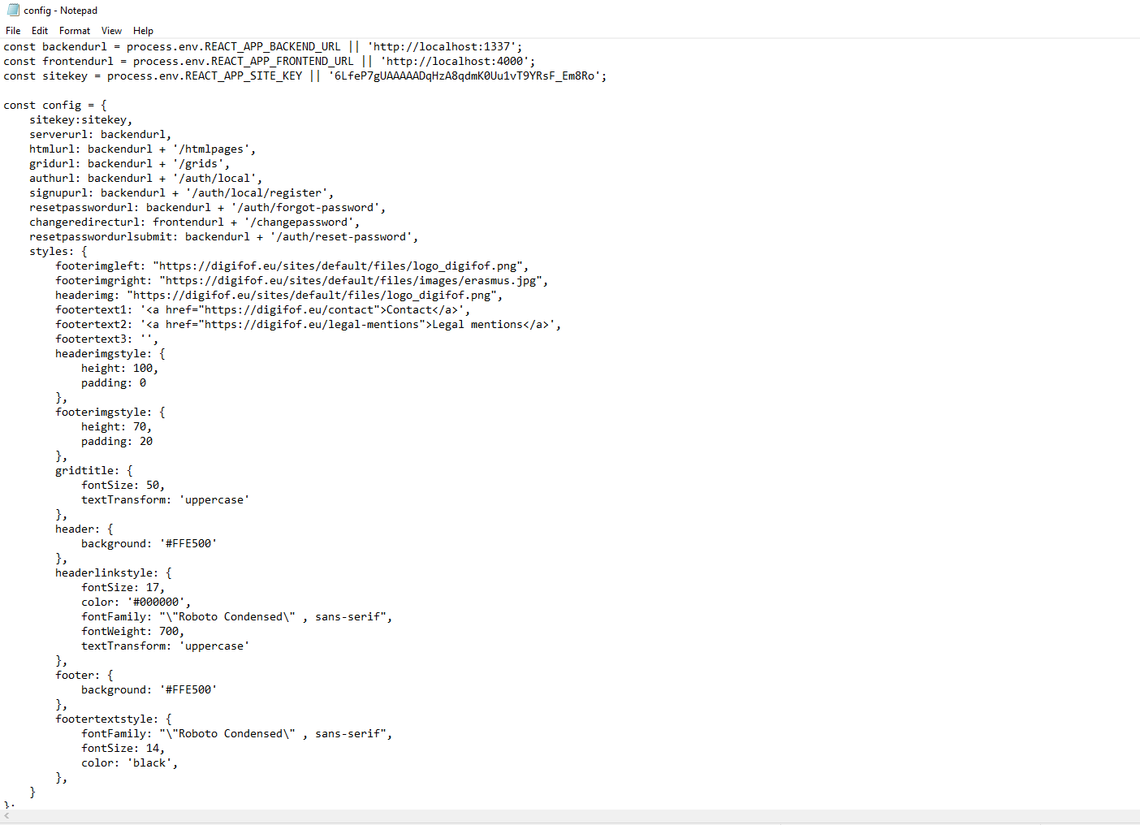
There is also possibility to adjust most important options using process env variables:
process.env.REACT_APP_BACKEND_URL
process.env.REACT_APP_FRONTEND_URL
process.env.REACT_APP_SITE_KEY
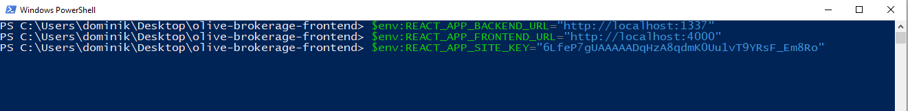
II.5 To enable new user registration, you also need to generate CAPTCHA site key, from https://www.google.com/recaptcha/admin
After adding your domain, update sitekey in src/config.js
You must also add your secret to ‘middlewares/validateUser/index.js’ in your backend api or using env variable:
process.env.SITE_SECRET (in your backend api process !)
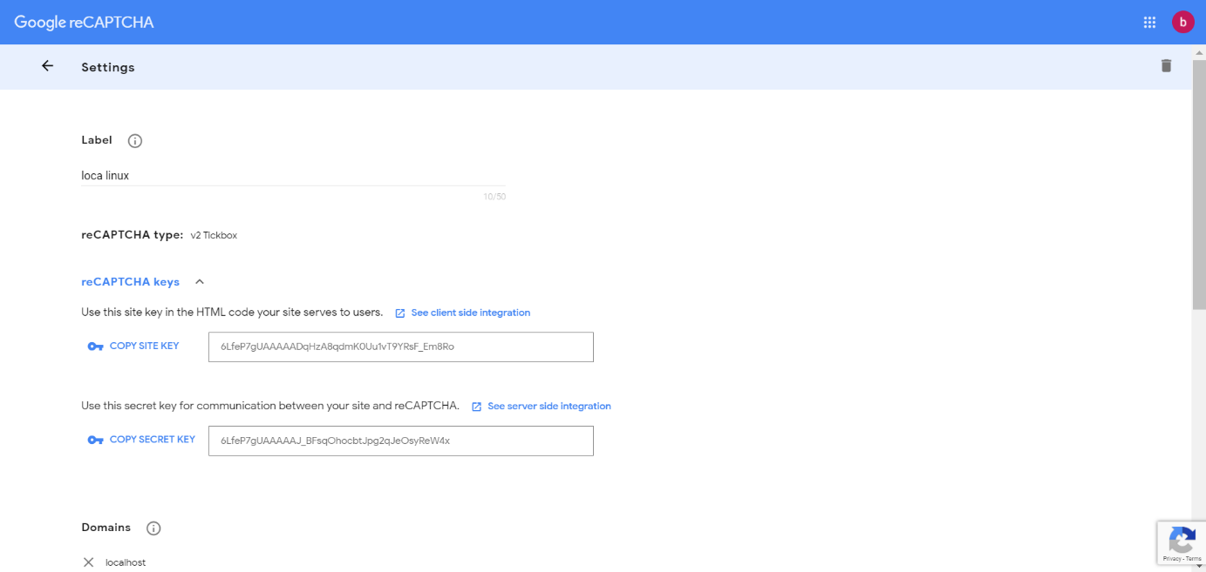
II.6 run:
npm run build
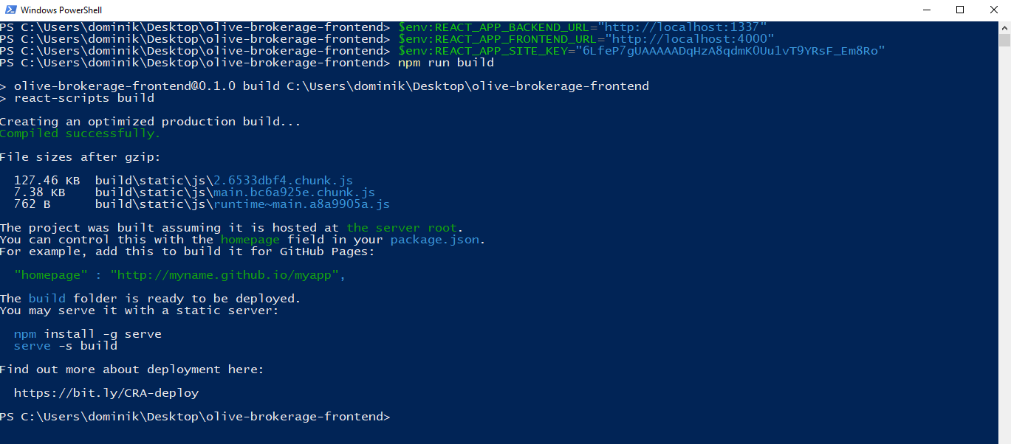
II.7 Host the built app (build folder)
Example hosting using serve:
npm install -g serve
serve -s build -l 4000
In above example, port where your app will be available is 4000 - you can adjust it to your needs
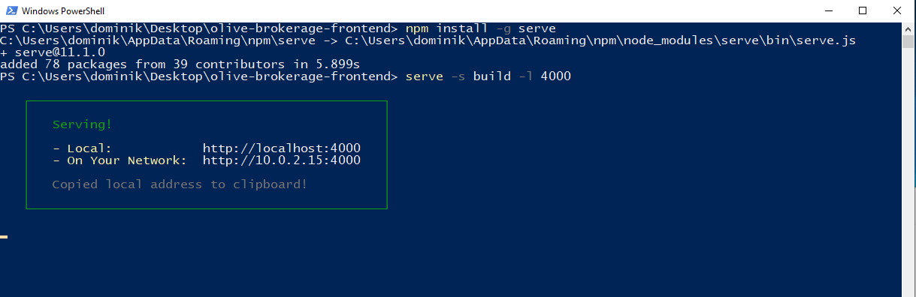
II.8 Having your back-end api deployed and front-end served, you should see your app server at the configured port, with example data
Please note, that if you host both apps on localhost, and you would like to test features like user registration, you would need to allow CORS in your browser (e.g. with Chrome plugin).
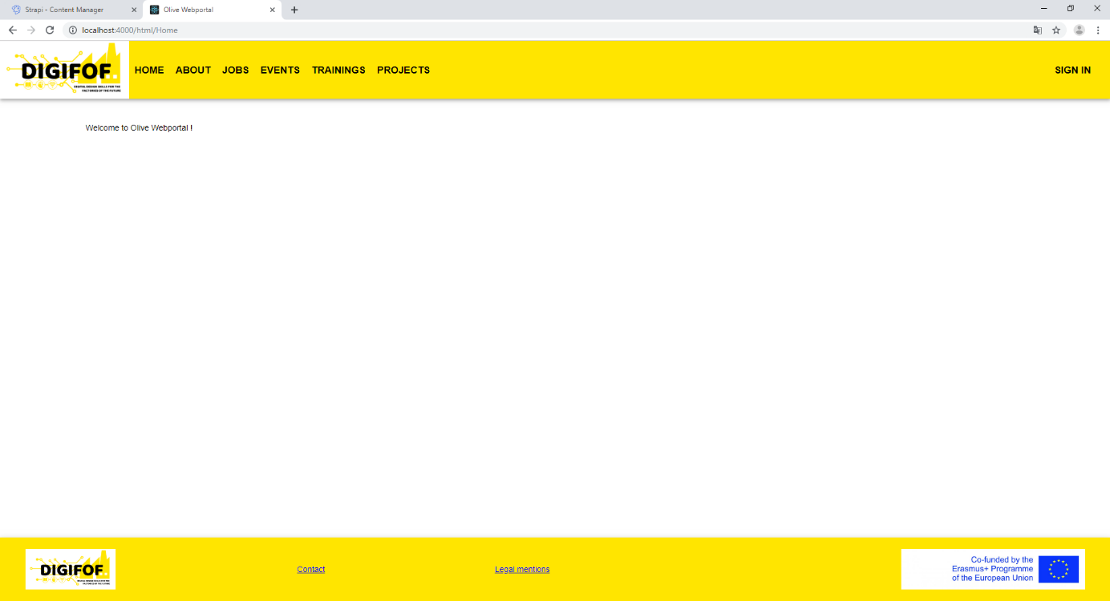
Further Questions
in case of problems and for more information contact us at faq@adoxx.org

Conclusion
The release of web platform installation files and guide will allow project partners to create their own installations of web-platform which, filled with the regionalized content, will create a communication and interaction hub with the stakeholders.

https://www.adoxx.org/live/olive
Copyright (c) 2015-2019 Strapi Solutions. Permission is hereby granted, free of charge, to any person obtaining a copy of this software and associated documentation files (the "Software"), to deal in the Software without restriction, including without limitation the rights to use, copy, modify, merge, publish, distribute, sublicense, and/or sell copies of the Software, and to permit persons to whom the Software is furnished to do so, subject to the following conditions: The above copyright notice and this permission notice shall be included in all copies or substantial portions of the Software.

