Project Title:
THE FOF-DESIGNER:
DIGITAL DESIGN SKILLS FOR FACTORIES OF THE FUTURE

Project Acronym:
DigiFoF

Grant Agreement number:
2018-2553 / 001-001

Project Nr. 601089-EPP-1-2018-1-RO-EPPKA2-KA

Subject:
Educational Material

EMSE_06: Deployment of Service-oriented Strategy

Authors
Nadine Dubruc
Sophie Peillon
Xavier Boucher

This project has received funding from the European Union’s EACEA Erasmus+ Programme Key Action 2 - Knowledge Alliances under the Grant Agreement No 2018-2533 / 001-001

Deployment of Service-oriented Strategy

CONTENT

- General introduction
- Module 1 : Understand the strategic innovation context of the company
- Module 2 : Apply a creativity design-thinking approach to an innovation project
- Module 3 : Anticipate the organizational impacts of service innovation
- Module 4 : Evaluate and discuss the applicability of innovation proposals

General introduction

This document provide educational support, to animate an interactive session of service-oriented diagnosis of enterprise innovation opportunities. The approach is more adapted to SMEs, with quite integrated decisional hierarchy, than to large companies. It is dedicated to industrial companies looking to develop service oriented business to transform their business model in the context of Industry of the Future. The whole interactive training is proposed to be applied in only one company for each training session.

The innovation context is considered here as ‘Product-Service-System’ innovation (PSS). That means that the service opportunities or developed along the life-cycle of industrial products, and can also lead to new economic models were the product is fully sold as a service (PaaS – Product as a Service).

The overall objective of the whole ‘service innovation session’ is to bring various complementary competencies of the company to work collaboratively on both strategic diagnosis and perspective development, so as to identify key strategical factors and incentive/resistance for service development and key opportunities for initiating the servitization transition. This approach can, thus, serve both as ‘vocational training’ of some key managers of the company concerning transition towards service, and as first strategical diagnosis to launch the internal innovation process.

The following document is an educational support, to help implement this approach locally. The document provide explanations and support to implement the four modules which structure the diagnosis. Each of these modules correspond to half a day of training/diagnosis session. The animators have to plan intermediary work between each module, to analyze the information collected and provide analysis insights.

In the following explanation we call ‘service innovation session’ the full set of 4 modules.

Module 1: Understand the strategic innovation context of the company

Introduction
The objective of this module is to understand and depict the context in which the company operates and within which its service strategy is integrated.
At the end of this module, participants will have a clear vision of this context, especially of the opportunities it offers to the company regarding the service development.

Outputs:
- Outputs of this context analysis can be presented by classical conceptual tools such as PESTEL and SWOT representations.

Module specification | Explanation
Module duration | 4 hours
Module objective | • Capture the key strategical factors to understand the innovation context of a company (SME)
Mode of provision | Directly in industrial context (by a company)
Laboratory structure | Time (min) | Objective | Performed by?
 | Needed time for this part | Objective that need to be obtained | Who perform in this part
 | 90 min | Capture strategical innovation situation and factors from the Top Management (SME Manager) | PSS Experts + Company Top Manager
 | 90 min | Capture strategical innovation situation and factors from the Marketing and R&D departments | PSS Experts + Managers of Marketing and R&D departments
 | 60 min | Capture strategical innovation situation and factors from the Production and Sales departments | PSS Experts + Managers of Production and Sales departments
 | At the end of this module key contextual factors for strategic innovation are synthesized in the form of PESTEL and SWOT diagrams.

Module content

The capture of the strategic innovation context needs to be performed working closely in collaboration with the company’s managers. Strong interactions and several face-to-face exchanges are needed to properly understand the context. This stage should really not be considered as anecdotal; rather it is clearly indispensable to build a trust-based relationship with the company’s managers, to raise awareness of services and PSS among them, and finally to be able to make relevant and suited proposition to the company.

Interviews are based on a questioning guide, which has to be specified according to each specific studied case could. This questioning guide is of course adapted to the 3 type of actors interviewed in the 3 steps of the module. The guide should notably include the following questions:

- Internal context of the company/the department (marketing, R&D, production, sales)
  - Activities and core competences, products and technologies, internal organization, key figures
  - Strengths and weaknesses

- External context of the company/the department (marketing, R&D, production, sales)
  - Market, customers, competitors
  - Opportunities and threats

- Focus on services
  - Do competitors offer services? Which ones?
  - Do customers need and ask for services? Which ones?
  - Existing services: What are they? How have they been developed? What is the underlying commercial organization? How are customer needs identified and answered? Who are the key “service people”?
  - Possible future services: Has a service strategy been formulated? Which one? Which services could/should the company develop in future years (short, medium, long term)?

PSS experts should also gather additional information regarding the market, the customers, the competitors, and the overall environment. All the information gathered could be synthetized based on tools such as a SWOT matrix or a PESTEL diagram.Examples from a company in the agricultural machinery sector are below.

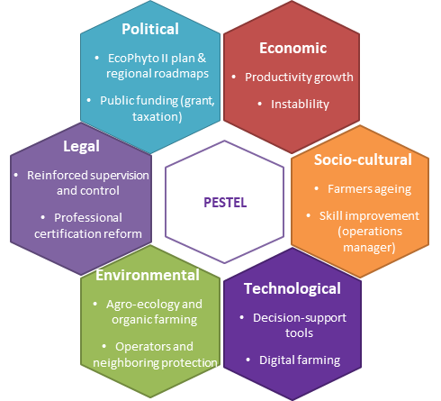

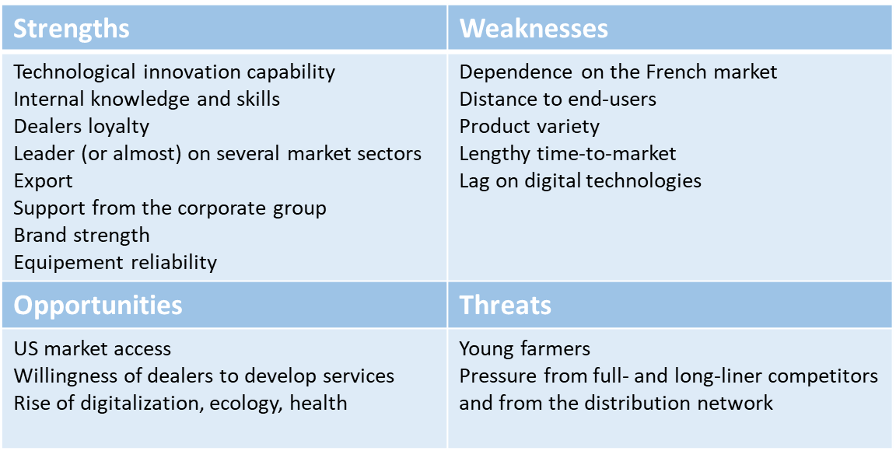

Module 2: Apply a creativity design-thinking approach to an innovation project

Introduction

For module 2 and further modules, the training and creativity sessions do focus on a specific innovation project of the company, and not on a general development of services.

The objective of this module is to create product-related service ideas and discuss them before implementing a deployment plan.

Outputs:
- Service opportunity catalogue: create imaginative new service-oriented offers, linked to a potential innovation project (on their proper business).
- List of prioritization criteria for service opportunity deployment
- Ranking of the service opportunity catalogue.

Module specification | Explanation
Module duration | 3,5 hours
Module objective | • Put the key innovation actors of a company in situation to create imaginative new service-oriented offers, linked to a potential innovation project (on their proper business)
Mode of provision | Directly in industrial context (by a company)
Laboratory structure | Time (min) | Objective | Performed by?
 | Needed time for this part | Objective that need to be obtained | Who perform in this part
 | 15 min | Share the objectives and structure of the session with all actors | PSS experts
 | 30 min | Make explicit the open usage expectations from different categories of clients | PSS Experts + Company Innovation Actors
 | 15 min | Synthesize and share the results | PSS Experts + Company Innovation Actors
 | 60 min | Create innovative PSS offers, through a design thinking mode | PSS Experts + Company Innovation Actors
 | 45 min | Synthesize and share the results of creativity session | PSS Experts + Company Innovation Actors
 | 45 min | Make explicit prioritization criteria and strategies concerning the potential deployment of PSS offers | PSS Experts + Company Innovation Actors
 | At the end of this module, the results should be synthesized in a structured ‘service opportunity catalogue’, where each service opportunity is characterized by its priorization criteria.

Module content

Schedules | Objective | Group | Subject | Duration
9:00-9:15 | Welcome | plenary | Presentation of the day and its objectives | 10’
 |  | plenary | Explain the rules of the day (put yourself "out of routine") | 5’
9:15-9:45 | Customer expectations |  | Session "breaking ice" : What keywords to define services in company? | 5’
 |  | Several subgroups | Creativity session: Presentation, explications. Breakdown of participants into subgroups (corresponding to the main types of clients).  Each subgroup identifies by being the typical customer the expectations of services towards the company. | 25’
9:45-10:00 |  | Plenary | restitution of each sub-group and discussions T5 : | 15’
10:00-11:00 | Panel of services |  | Introduction for how create innovative PSS offers, through a design thinking mode | 10’
 |  | 2 groups | Individual work, ideas on colored post-it, in connection with the cards. Role play: I put myself in the client's shoes and I imagine what he is "waiting" | 10’
 |  | 2 groups | Filling the collective support: the Empathy Map support. Everyone comes to post his post-it and comments.  We eventually complete | 40’
11:10  11:15 | break
11:15-11:45 | Restitution | plenary | Joint return: exhibition and explanation of the two heads | 30’
11:45  -  12:10 | Prioritization | plenary | Make explicit prioritization criteria and strategies concerning the potential deployment of PSS offers.  Resumption of identified services  Prioritization of services by ranking the most important ones to develop for the company | 25’
12:0512:10 |  | plenary | Closing debriefing | 5’

Design thinking focuses on empathy, listening and observing customers. It is about better understanding customer expectations, identifying levers to improve the customer experience. We use some tools of design thinking and some PSS tools:

- Bring out ideas from persona and empathy map :
It's about being human-centered so that it is possible to identify with clients/users. We seek to create an understanding of the client through the creation of a sense of empathy, to put ourselves in the client's shoes, to see through the client's eyes, to understand his positive or negative emotions, his beliefs, his environment...
  - Persona :
A persona is a fictional character that represents a type of customer or user of a service or product. We're looking for a description of personas. Ideally, this portrait should fit on an A4 page and summarize all relevant information: a name, a surname; an age; an activity; a historical context ; an economical context; his needs; his goals…
  - Empathy map :
The empathy map seeks to determine how the client's ecosystem impacts their needs and expectations. It can be broken down into six points:
- the client's environment
- the influence of this environment on the client
- customer concerns
- the customer's attitude and discourse
- the customer's points of suffering
- the gains and values targeted by the client.

Find below an example of Empathy Map :
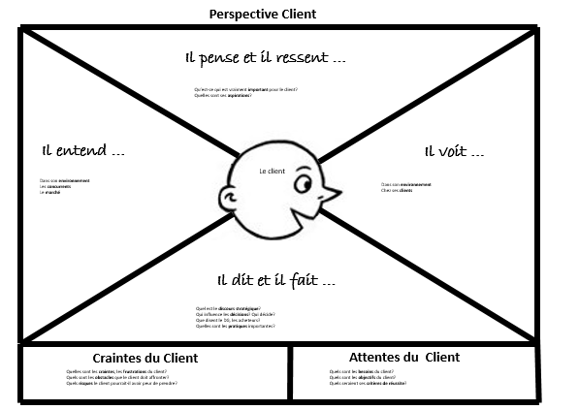Before
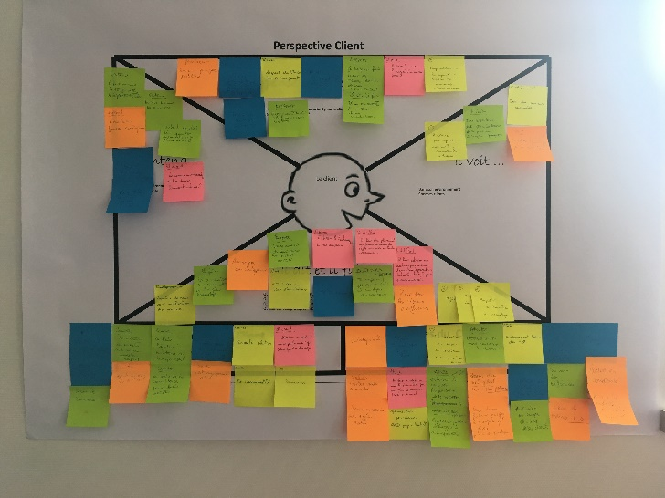 After

- PSS typology :
A PSS Typology is proposed to guide creativity on service opportunities. This typology is presented in [Boucher & Peillon, 2015]. As presented in the figure, the classification is constituted of two levels, with five service categories on the first level, further refined on the second one. Each category refers to some opportunity to develop services associated to an industrial product. Generic examples of each category have been specified as a creativity support.
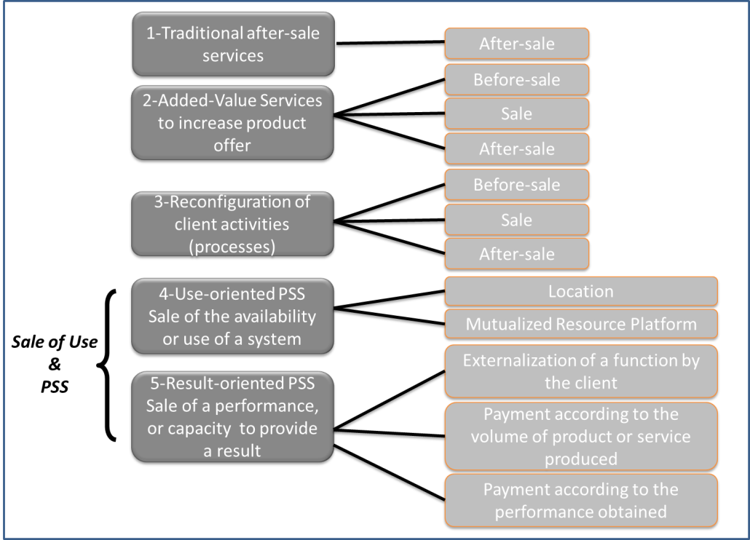

Module 3: Anticipate the organizational impacts of service innovation

Introduction
At this stage of the overall ‘Service Innovation Session’, the previous module 2 has generated a catalogue of service opportunities which has been characterized according to various priority criteria.

The objective of module 3 is to build an anticipatory analysis of the organizational impacts of the potential deployment of this service catalogue, according to the following points of view:
- Organizational obstacles or difficulties for service implementation;
- Needs of competence development and acquisition;
- Identification of key criteria to organize a progressive deployment of the catalogue over time (potentially a long period).
Thus, the overall objective is to make the decision-makers aware of key change management issues linked to service deployment.

Outputs:
- List of success factors and organizational obstacles associated to the service catalogue ;
- Representation of the ‘to be’ life-cycle of the innovative PSS
- Map of competence requirements for the innovation project
- List of criteria for a progressive deployment of servitization.

Module specification | Explanation
Module duration | 3 hours as a minimum
Module objective | Make explicit the organisational impacts of developing innovative PSS offers, both on internal and external collective competencies
Mode of provision | Directly in industrial context (by a company)
Laboratory structure | Time (min) | Objective | Performed by?
 | Needed time for this part | Objective that need to be obtained | Who perform in this part
 | 60 min | Analyse the key organisational obstacles and success factors induced by an innovative service catalogue | PSS Experts + Innovation Actors
 | 60 min | Analyse the new requirements of internal and external competencies all along the life cycle of the new PSS offer | PSS Experts + Managers of key departments of the company
 | 60 min | Discuss the priorities and progressive strategies, for organisational change management | PSS Experts + Top Management + key innovation actors
 | AT the end of this module all information available should be synthesized in a specific format to support module 4. This includes competence maps and transformation trajectories as emphasized in module 4.

Module content
Pre-amble: to support the analysis a representation of the life cycle of the PSS offer can be useful. Before further analysing deployment obstacles or requirements for competence development and acquisition, a preparatory work by the expert consists in providing a graphical representation of the life-cycle of the PSS offer under innovation. This life-cycle view makes it easier to position all service opportunities along the various life-cycle stages. An example of representation if provided below in section 4.2.2.

4.2.1. First step: Organizational obstacles and success factors.

The initial Input to analyze obstacles and success factors is of course the catalogue of service opportunities resulting from module 2. The service catalogue can be first refined by specifying if distinct service levels for the customers should be considered at the implementation stage.
The conceptual model of the service catalogue becomes more detailed:
Service component
(Required skills & activities)
is characterized by
is part of
Service
Opportunity

Service
Catalogue

Service levels
Organizational Obstacles
Organisational Success factors

Based on this catalogue, experts proceeds to a systematic identification of the impacts generated by the development of new services in each phase of the PSS life-cycle, on the following organizational factors: network of partners, customer relationship management, design of the technical system, and manufacturing or service processes. The identification is based on dedicated interviews of technical actors of the company for each stage of the life-cycle. This analysis intends to provide a quite exhaustive identification of local transformations affecting the organization, which can be classified in terms of organization obstacles or success factors.

4.2.1. Second step: requirements for internal and external competencies

This steps anticipates the impacts of new service development on competencies, either to be developed internally or to be acquired by collaborations.

Here again, a life cycle vision is useful. A first representation consists in identifying the key competence requirements along the various stages of the life cycle.

An example is provided below, linked to a company called B-SME, offering BtoB solutions in the field of chromatography equipment (also called chromatography columns, and LPLC equipment) for industrial production. The diagram emphasizes key new skills identified along the equipment life cycle, for the need a developing a ‘Ready-to-use’ market offer (Boucher & Peillon, 2015).

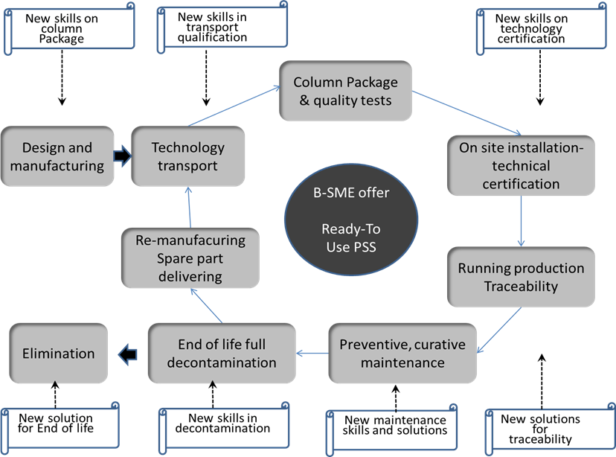

A complementary useful tool proposed is a structured identification of competence impacts for the working processes impacted by the innovation. Such competence identification can be initiated during the meeting, then finished by the company actors as complementary tasks. An example of competence table is provided below for the case of the B-SME.

Key process : in-use equipment maintenance (by the customer)
 | Short term transformation plan |  | Long term transformation plan
Internal technical competencies |  | - Need of new maintenance planning methods, based on process data provided by the customers | - Advanced maintenance planning methods, including: (i) predictive maintenance, (ii) on-distance supervision of equipment working conditions
Internal transversal competencies |  | Legal skills : contractualization of responsibilities and risks  Information System : process and performance traceability  Marketing : marketing of a new offer oriented on predictive maintenance
External skills/relationships |  | Develop new forms of collaboration with an extended network of providers required to enlarge product functionalities supporting maintenance.
Customer Relationship Management |  | Development of an increase level of customer data sharing | Co-development with key users of a predictive maintenance offer

4.2.1. Third step: prescription of progressive change management, to address the transformation effort required

This third step is dedicated to question the progressivity of the transformation plan required for new service deployment. The previous steps provides of course an important input with the identification of the new skills required. This information can be synthesized together with the new service catalogue resulting from module 2, to highlight the panel of new skills to be developed. An example is provided below, for the same case study of the B-SME.

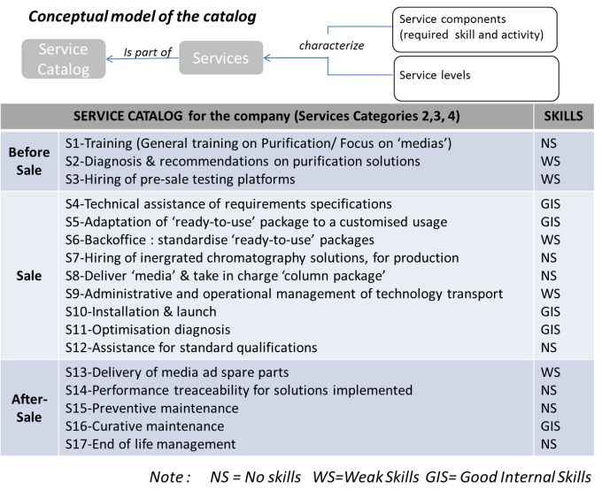
Based of these first inputs, temporal priorities in the deployment of the service catalogue should be identified by the decision-makers taking into account two key orientations:
- The effort required to implement the new services (effort in terms of investment, competence development, change of internal culture…);
- The acceptability for the external market.
A second important point linked to the temporality and progressivity of the transformation, is to consider the current strength of the company in terms of service development. This lead to try and identify in the company a so-called ‘initial driver’ of service development, that means a first key orientation of service development which would be both easily accessible and consistent with the current industrial culture of the company. This initial driver should become a successful pilot project of service innovation.

Module 4: Evaluate and discuss the applicability of innovation proposals

Introduction
The objective of this last module, part the whole diagnosis procedure, is to confront the results and synthesis of the previous modules with the feedback from the key decision-makers of the company.
This module requires a preliminary work, to present the results of the whole diagnosis procedure via a synthetic format, to make easier the interaction with decision-makers.

Outputs of the module
- Decision-makers feedback on the innovation plan proposed;
- Final adaptation of the innovation plan, based on this feedback.

Module specification | Explanation
Module duration | 4 hours
Module objective | • Confront the innovation path proposed, to the experience of the company managers
Mode of provision | Directly in industrial context (by a company)
Laboratory structure | Time (min) | Objective | Performed by?
 | Needed time for this part | Objective that need to be obtained | Who perform in this part
 | 30 min | Presentation of the service catalogue and PSS offers resulting from the previous steps | PSS Experts
 | 60 min | Open discussion | Company managers
 | 30 min | Presentation of the organisation transformation path proposed | PSS Experts
 | 60 min | Open discussion | Company managers
 | After this 4 hour session, a final report of the results should be written, by integrating the feedback from the discussions.

Module content

Part 1 - Presentation of the service catalogue and PSS offers resulting from the previous steps

The catalogue of service opportunities, graphically represented in section 4.2.3, is presented to the company decision-makers and structured within a deployment temporality: which package of services should be developed at short-, mid- and long-term. This temporality can be coupled with the customer typology, highlighting a differentiation of service packages according to user profiles and expectations.

A presentation of the transformation of the offer life-cycle is an interesting complement to the service catalogue, to emphasize the new skills to be developed all along the life cycle.

These two synthetic presentations are the input of the first feedback discussion with the decision-makers. This discussion should focus on the pertinence and consistency of the service packages proposed, with regards to the innovation and market strategy of the company.

Part 2: Presentation of the organisation transformation path proposed

In this part, experts and people from the company will discuss about the restitution made by the PSS experts about a proposal of a possible trajectory of change to develop services.
During 30 minutes, the PSS experts will present the proposals of possible trajectories for changing the Company’s services orientation.
Then, for 60 minutes, the experts let the company managers speak and answer questions.
The proposals may be adjusted in the final report in the light of the discussion.

In the presentation, all this information is restructured and presented according to a progressive plan of transformation, associated with so called ‘maturity degrees’, for the transition towards a fully integrated PSS solution. The various degrees of maturity towards the final target are not considered as generic in the approach, but as contextualised for each company. Indeed, the progressivity of the whole transformation plan deeply depends on the organizacional context, on the PSS considered, on the external factors, on specific opportunities: all these aspects are fully link with the context.

As a result for that fourth step, the approach provides:
- A proposal of various maturity degrees, specifically adapted to the firm context;
- A set of matrices, used to characterize each maturity degree by the main changes it implies on key company collectives capabilities;
- A systematic identification of local transformations affecting the organization, for each phase of the PSS life-cycle.

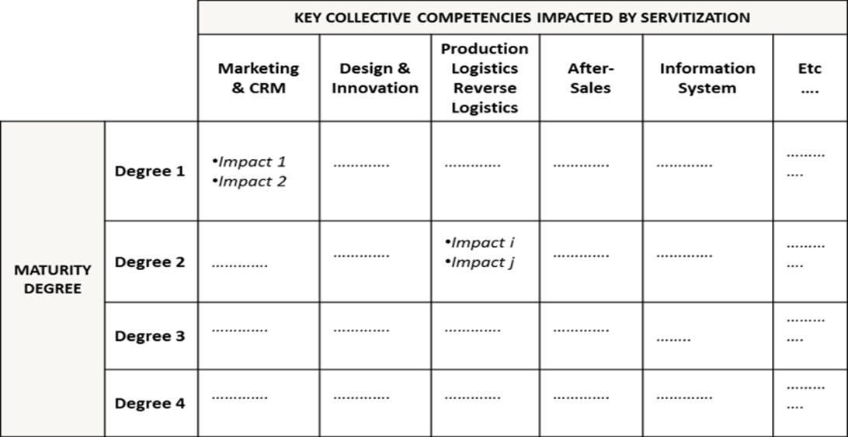

An example if provided by the B-SME case study. The figure below underlines a graphical synthesis of some of the results of this final step of the diagnosis. First, a systematic (exhaustive) identification of local organisation transformations was realized, to take into account all changes identified in each phase of the PSS life-cycle. Then, this local organisational information was structured within a progressive plan of enterprise transformation, associated with so-called ‘maturity degrees’ for the progressive servitisation path. The transformation plan is fully contextualised. As illustrated by Figure 4, four maturity degrees were identified for B-SME. Each of these maturity degrees was characterised by a so-called ‘Matrix of servitisation impacts on collective competences’.
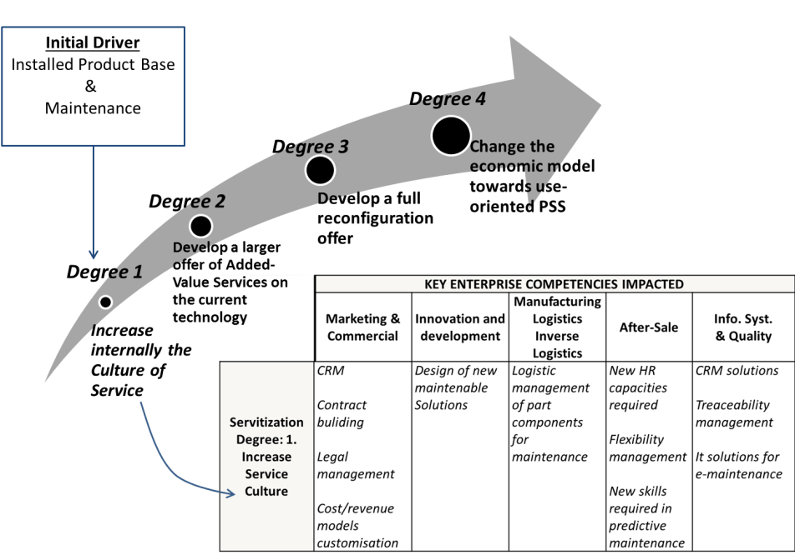

Bibliography

Boucher X., Peillon S., Diagnosis of Servitisation Potential - Proposal of a Strategic Diagnosis Framework dedicated to SMEs, WECC2015, World Engineering Conference and Convention 2015, Track Industry for Society, Kyoto, Japan, November 29-December 2, 2015

Dubruc N., Peillon S. (2019). Human resources barriers in SME’s digital servitization : french case studies. Proceedings of the Spring Servitization Conference. Delivering Services Growth in the Digital Era. Spring Servitization Conference 2019. 13 - 15 May 2019, Linköping, Sweden. ISBN 978 1 85449 463 4. pp. 261-263. (Poster)
Peillon S., Dubruc N. (2019). Barriers to digital servitization in French manufacturing SMEs. Procedia CIRP, ELSEVIER, 2018, 11th CIRP Conference on Industrial Product-Service Systems, IPS2 2019, 29-31 May 2019, Zhuhai & Hong Kong, China, pp 146-150.
Peillon S, Dubruc N., Mansour M. (2018). Service and customer orientation of corporate culture in a French manufacturing SME. Procedia CIRP, ELSEVIER, 2018, 10th CIRP Conference on Industrial Product-Service Systems, IPS2 2018, 29-31 May 2018, Linköping, Sweden, 73, pp 91-95.
Peillon S., Medini K., Dubruc N. (2016). An initial training program on Product-Service Systems and servitization for engineering students. Procedia CIRP 8th Product-Service Systems across Life Cycle, Jun 2016, Bergame, Italy. Elsevier, In Press.
Derrouiche R., Dubruc N. (2014). Towards a framework for analyzing and evaluating Servitization Potential, Case study of ENVIE Loire, PRO-VE' 14, 15th IFIP WG 5.5 Working Conference on Virtual Enterprises, Amsterdam, The Netherlands, October 6-8, 2014. Springer, ISBN: 978-3-642-44744-4. pp 135-142.
Dubruc N., Peillon S., Farah A. (2014). The impact of servitization on corporate culture, IPSS 2014. Product Services Systems and Value Creation. Proceedings of the 6th CIRP Conference on Industrial Product-Service Systems. Procedia CIRP. Volume 16, pp 289-294.
Dubruc N., Peillon S., Farah A. (2014). The customer-supplier contract as a boundary-object within the servitization process, SSC 2014. Proceedings of the Spring Servitization Conference. 12-14 May 2014. ISBN 978 1 85449 472 6. pp. 104-112.

